Slot A (11-21)
11.Program
data <- data.frame(
Name = c("Arun", "Bala", "Chitra"),
Marks = c(85, 90, 78)
)

write.csv(data, "students.csv", row.names = FALSE)

result <- read.csv("students.csv")

print(result)
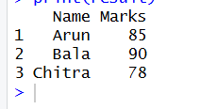
RESULT:
Hence the output is verified
12.PROGRAM
data("airquality")

result <- aggregate(
cbind(Ozone, Solar.R, Wind, Temp) ~ Month,
data = airquality,
FUN = mean,
na.rm = TRUE
)

print("Monthly average values:")
print(result)
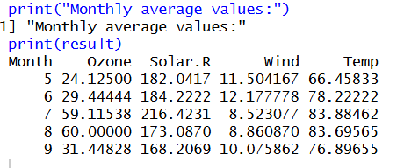
RESULT
Hence the output is verified
13.PROGRAM
rm(list = ls())

a <- c(1, 2, 3)
b <- c(4, 5, 6)
c <- c(7, 8, 9)

d <- rbind(a, b, c)

print("Combined arrays (row-wise):")
print(d)
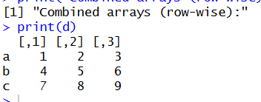
RESULT:
Hence the output is verified
14.PROGRAM
# Load the built-in dataset
data(ChickWeight)

# Display the first few rows
print("First few rows:")
print(head(ChickWeight))

# Sort the dataset by weight in ascending order
sorted_data <- ChickWeight[order(ChickWeight$weight), ]

print("Sorted data:")
print(head(sorted_data, 10))

# Calculate average weight for each Diet
avg_weight <- aggregate(weight ~ Diet,
data = ChickWeight,
FUN = mean)

print("Average weight by Diet:")
print(avg_weight)
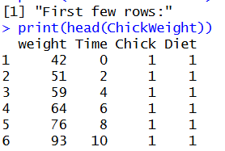
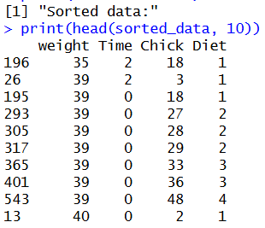
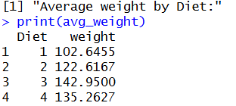
RESULT
Hence the output is verified
15.PROGRAM
data("iris")

dim(iris)
summary(iris)

sapply(iris[,1:4], sd)

quantile(iris$Sepal.Length)

aggregate(. ~ Species, iris, mean)
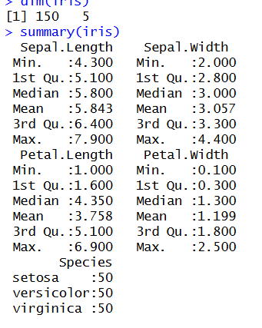
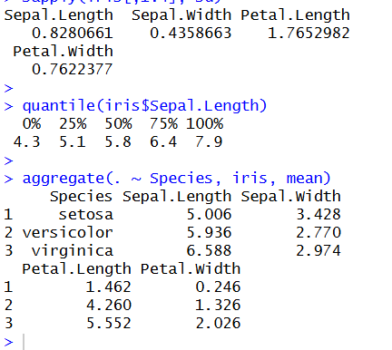
RESULT
Hence the output is verified
16.PROGRAM
data("USArrests")

summary(USArrests)

which.max(USArrests$Rape)

max(USArrests$Murder)

min(USArrests$Murder)

cor(USArrests)

hist(USArrests$Murder)
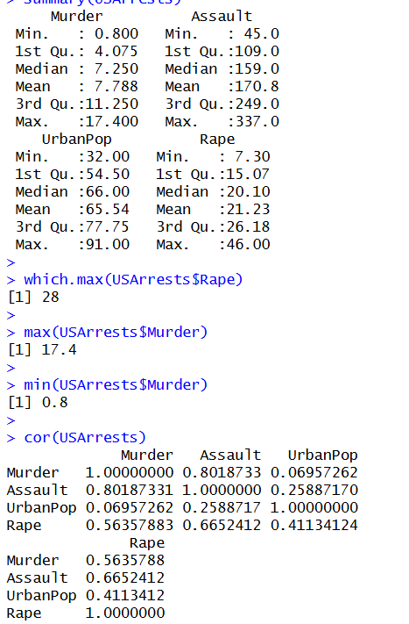
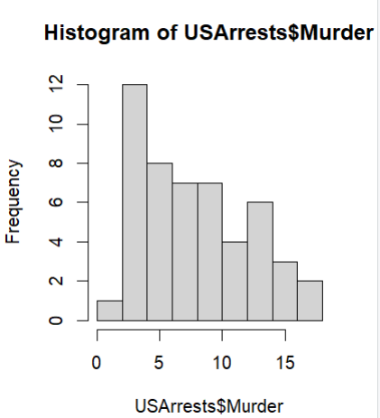
RESULT
Hence the output is verified
17.PROGRAM
data("Titanic")

t <- as.data.frame(Titanic)

barplot(
table(t$Class, t$Survived),
main = "Survival vs Class",
beside = TRUE
)

barplot(
table(t$Sex, t$Survived),
main = "Survival vs Gender",
beside = TRUE
)
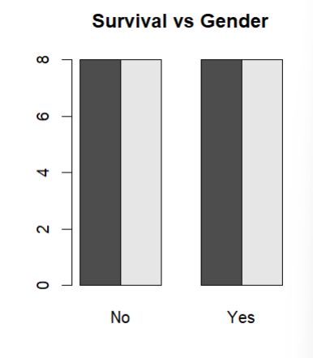
RESULT
Hence the output is verified
18.PROGRAM
x <- c(10, 20, 30, 40, 50)
y <- c(5, 15, 25, 35, 45)

par(mfrow = c(2, 3))

boxplot(x, main="Boxplot", col="lightblue")

hist(x, main="Histogram", col="lightgreen")

barplot(x, main="Bar Plot",
col="orange",
names.arg=c("A","B","C","D","E"))

plot(x, type="l", main="Line Chart", col="blue")

plot(x, y, main="Scatter Plot", col="red")
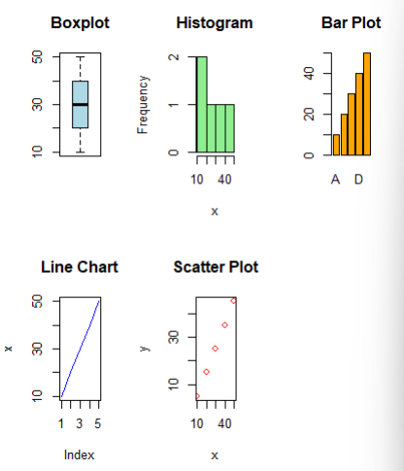
RESULT
Hence the output is verified
19.PROGRAM
Spend <- c(10, 20, 30, 40, 50)
Sales <- c(15, 25, 35, 45, 55)

model <- lm(Sales ~ Spend)

predict(model, data.frame(Spend = 60))

RESULT
Hence the output is verified
20.PROGRAMdata("ChickWeight")

m <- lm(weight ~ Time + Diet, data = ChickWeight)

p <- predict(m)

mean((ChickWeight$weight - p)^2)
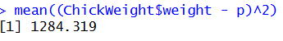
RESULT
Hence the output is verified
21.PROGRAM
data("iris")

iris <- subset(
iris,
Species %in% c("setosa", "versicolor")
)

m <- glm(
Species ~ Petal.Length + Petal.Width,
data = iris,
family = binomial
)

p <- ifelse(
predict(m, type="response") > 0.5,
"versicolor",
"setosa"
)

table(p, iris$Species)
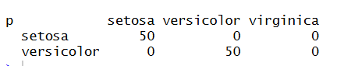
RESULT
Hence the output is verified

